5.1 PSYCHIATRIC SERVICES

REQUEST FOR QUALIFICATIONS

APPLICATION

INSTRUCTIONS

    - Application must be completed and signed in Section 6 (Certification) for it to be accepted by DFPS.
    - Applicant will submit Application and all required documents in the format and order described in Appendix A to the Point of Contact in Request for Qualifications (RFQ) Section 1.2.
    - If DFPS has difficulty accessing the Applicant’s documents, the Applicant will be required to re-submit documents as directed by DFPS.

- APPLICANT INFORMATION

Legal Name of Applicant/Entity
Office Address
City, State, Zip
Mailing Address
City, State, Zip
Phone
Vendor ID Number: | Federal ID Number – If different from Vendor ID:  Applicant:  Parent Organization:
Doing Business As Name (DBA) or Parent Organization – If different from Legal Name above:

Attach a copy of Assumed Name Certificate

If an Applicant has a Parent Organization, attach a copy of the agreement between the Applicant and the Parent Organization
Type of Applicant – Check appropriate box(es) and attach documentation as indicated
Sole Proprietorship
Private Corporation  For Profit  Non-Profit | State of Incorporation:  Charter Number:  Attach a copy of Certificate of Incorporation
Limited Liability Company (LLC) | Attach a copy of the Articles of Formation
Partnership  Limited  General | Attach a list of names, addresses for each partner and provide a copy of the Partnership Agreement.
Governmental Entity
Do you have taxing authority? Yes No
Are you a certified Texas HUB?
Yes – Attach a copy of HUB certification form.
No – Select all that apply if you fall into one or both of the categories
below:
Minority Owned Business Woman Owned Business
Person Authorized to Sign Contract:
Name |  | Title
E-mail |  | Phone
Contact for Service Delivery:
Name |  | Title
E-mail |  | Phone
Contact for Invoicing:
Name |  | Title
E-mail |  | Phone

- ELIGIBILITY REQUIRMENTS
(See Section 2.13 Service Provider Minimum Qualifications of the Contract)

  - Does the Service Provider(s) hold a Texas Medical Board license, that is unencumbered at the time this Application is submitted?

Yes
No If no, STOP – Applicant does not qualify.

  - Does the Service Provider(s) hold a Specialty Board Certification in Psychiatry?

Yes If yes, attach copy of License.
No If no, STOP – Applicant does not qualify.

- CONTRACTOR BACKGROUND

  - Does the Applicant have contracts with DFPS or other State Agencies?
Yes No

If yes,

Is the Applicant's organization currently under any corrective action plan for any of the contracts with DFPS or State Agencies?
Yes No

  - Have any contracts been terminated for cause in the last five (5) years?
No Yes (Provide copies of termination notice)

- FEE SCHEDULE: In proposing a rate, the maximum rate per hour must not exceed $300.00.

Note: There is no minimum amount requirement.

SERVICE TYPE | Unit of Service | UNIT RATE
PSYCHIATRIC EVALUATION | A completed psychiatric evaluation which includes face-to-face with client; preparation of documents; testing and write-up. | Current Medicaid Rate (check if willing to accept the Medicaid rate) | Proposed Rate $ (enter proposed rate above)
DIAGNOSTIC CONSULTATION | *per hour | $
COURT RELATED SERVICES | *per hour | $

- INSURANCE

Review the minimum requirements in RFQ Section 2.16 Contractor Insurance Requirements. Applicants must meet all requirements as outlined. Indicate in the table below if requirement is met:

Commercial General Liability  Yes No | Applicant does not have required Commercial General Liability insurance, but will obtain within the RFQ defined timeframe:  Yes No
Professional Liability Insurance  Yes No | Applicant does not have required Professional Liability Insurance, but will obtain within the RFQ defined timeframe:  Yes No

Unless the contractor is self-insured, the DFPS certificate of insurance is the only acceptable proof of insurance.

- SERVICE DELIVERY LOCATIONS

- You must determine which counties will be served and mark them in Attachment A-4 Service Delivery Areas. Contractor must provide services within each county selected.

- Will you, your staff, or other subcontractors be delivering telehealth services in addition to in-person services? Note: If you elect to provide telehealth services, you must also provide in-person services in the same region(s) and counties in which you are electing to provide telehealth services.

Yes No

- CERTIFICATION

I certify that the information provided in this application is, to the best of my knowledge, complete and accurate; that the named legal entity has authorized me, as its representative, to submit this application; and that the legal entity complies with all terms of this Request for Qualifications.
Signature of Authorized Representative | Date
Name of Authorized Representative (Printed) | Title of Authorized Representative (Printed)

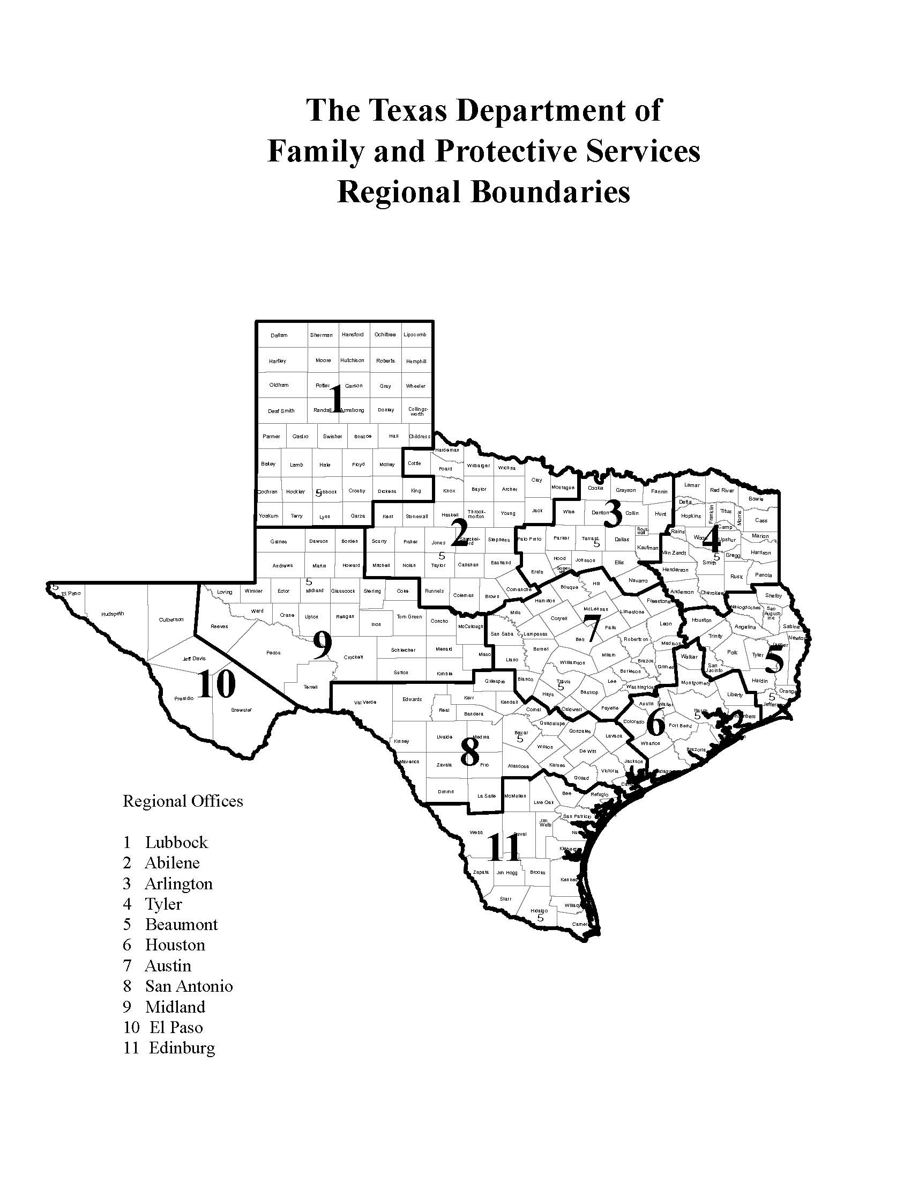

Attachment A-4 Service Delivery Area

Service Delivery Area
Counties To Be Served – Region 1
Choose the counties within the Region where services will be provided. Check the box in front of the county name. Choose a single county or any combination of counties.
Regional Counties
Armstrong |  | Hockley
Bailey |  | Hutchinson
Briscoe |  | King
Carson |  | Lamb
Castro |  | Lipscomb
Childress |  | Lubbock
Cochran |  | Lynn
Collingsworth |  | Moore
Crosby |  | Motley
Dallam |  | Ochiltree
Deaf Smith |  | Oldham
Dickens |  | Parmer
Donley |  | Potter
Floyd |  | Randall
Garza |  | Roberts
Gray |  | Sherman
Hale |  | Swisher
Hall |  | Terry
Hansford |  | Wheeler
Hartley |  | Yoakum
Hemphill

Service Delivery Area
Counties To Be Served – Region 2
Choose the counties within the Region where services will be provided. Check the box in front of the county name. Choose a single county or any combination of counties.
Regional Counties
Archer |  | Kent
Baylor |  | Knox
Brown |  | Mitchell
Callahan |  | Montague
Clay |  | Nolan
Coleman |  | Runnels
Comanche |  | Scurry
Cottle |  | Shackelford
Eastland |  | Stephens
Fisher |  | Stonewall
Foard |  | Taylor
Hardeman |  | Throckmorton
Haskell |  | Wichita
Jack |  | Wilbarger
Jones |  | Young

Service Delivery Area
Counties To Be Served – Region 3
Choose the counties within the Region where services will be provided. Check the box in front of the county name. Choose a single county or any combination of counties.
Regional Counties
Collin |  | Johnson
Cooke |  | Kaufman
Dallas |  | Navarro
Denton |  | Palo Pinto
Ellis |  | Parker
Erath |  | Rockwall
Fannin |  | Somervell
Grayson |  | Tarrant
Hood |  | Wise
Hunt

Service Delivery Area
Counties To Be Served – Region 4
Choose the counties within the Region where services will be provided. Check the box in front of the county name. Choose a single county or any combination of counties.
Regional Counties
Anderson |  | Marion
Bowie |  | Morris
Camp |  | Panola
Cass |  | Rains
Cherokee |  | Red River
Delta |  | Rusk
Franklin |  | Smith
Gregg |  | Titus
Harrison |  | Upshur
Henderson |  | Van Zandt
Hopkins |  | Wood
Lamar

Service Delivery Area
Counties To Be Served – Region 5
Choose the counties within the Region where services will be provided. Check the box in front of the county name. Choose a single county or any combination of counties.
Regional Counties
Angelina |  | Polk
Hardin |  | Sabine
Houston |  | San Augustine
Jasper |  | San Jacinto
Jefferson |  | Shelby
Nacogdoches |  | Trinity
Newton |  | Tyler
Orange

Service Delivery Area
Counties To Be Served – Region 6
Choose the counties within the Region where services will be provided. Check the box in front of the county name. Choose a single county or any combination of counties.
Regional Counties
Austin |  | Liberty
Brazoria |  | Matagorda
Chambers |  | Montgomery
Colorado |  | Walker
Fort Bend |  | Waller
Galveston |  | Wharton
Harris

Service Delivery Area
Counties To Be Served – Region 7
Choose the counties within the Region where services will be provided. Check the box in front of the county name. Choose a single county or any combination of counties.
Regional Counties
Bastrop |  | Hill
Bell |  | Lampasas
Blanco |  | Lee
Bosque |  | Leon
Brazos |  | Limestone
Burleson |  | Llano
Burnet |  | Madison
Caldwell |  | McLennan
Coryell |  | Milam
Falls |  | Mills
Fayette |  | Robertson
Freestone |  | San Saba
Grimes |  | Travis
Hamilton |  | Washington
Hays |  | Williamson

Service Delivery Area
Counties To Be Served – Region 8
Choose the counties within the Region where services will be provided. Check the box in front of the county name. Choose a single county or any combination of counties.
Regional Counties
Atascosa |  | Karnes
Bandera |  | Kendall
Bexar |  | Kerr
Calhoun |  | Kinney
Comal |  | La Salle
De Witt |  | Lavaca
Dimmit |  | Maverick
Edwards |  | Medina
Frio |  | Real
Gillespie |  | Uvalde
Goliad |  | Val Verde
Gonzales |  | Victoria
Guadalupe |  | Wilson
Jackson |  | Zavala

Service Delivery Area
Counties To Be Served – Region 9
Choose the counties within the Region where services will be provided. Check the box in front of the county name. Choose a single county or any combination of counties.
Regional Counties
Andrews |  | Mason
Borden |  | McCulloch
Coke |  | Menard
Concho |  | Midland
Crane |  | Pecos
Crockett |  | Reagan
Dawson |  | Reeves
Ector |  | Schleicher
Gaines |  | Sterling
Glasscock |  | Sutton
Howard |  | Terrell
Irion |  | Tom Green
Kimble |  | Upton
Loving |  | Ward
Martin |  | Winkler

Service Delivery Area
Counties To Be Served – Region 10
Choose the counties within the Region where services will be provided. Check the box in front of the county name. Choose a single county or any combination of counties.
Regional Counties
Brewster |  | Hudspeth
Culberson |  | Jeff Davis
El Paso |  | Presidio

Service Delivery Area
Counties To Be Served – Region 11
Choose the counties within the Region where services will be provided. Check the box in front of the county name. Choose a single county or any combination of counties.
Regional Counties
Aransas |  | Live Oak
Bee |  | McMullen
Brooks |  | Nueces
Cameron |  | Refugio
Duval |  | San Patricio
Hidalgo |  | Starr
Jim Hogg |  | Webb
Jim Wells |  | Willacy
Kenedy |  | Zapata
Kleberg

Satellite Offices and Additional Office Information:

Please provide a schedule in the table(s) below indicating days and times routinely available to provide services at each service location. These represent only routine days and times. Applicant will be expected to adjust schedule to accommodate the needs of clients and DFPS. Refer to PEN Section 2.5 for additional information. Use additional copies of this section, as necessary, to provide complete information.

Name of Applicant/Contractor

1.
Service Delivery Address
City, State, Zip
Phone |  | Fax
Contact Person |  | E-mail

 | HOURS
DAY | From | To | From | To
Example | 7 AM | Noon | 2 PM | 7 PM
Monday
Tuesday
Wednesday
Thursday
Friday
Saturday
Sunday

2.
Service Delivery Address
City, State, Zip
Phone |  | Fax
Contact Person |  | E-mail

 | HOURS
DAY | From | To | From | To
Monday
Tuesday
Wednesday
Thursday
Friday
Saturday
Sunday

3.
Service Delivery Address
City, State, Zip
Phone |  | Fax
Contact Person |  | E-mail

 | HOURS
DAY | From | To | From | To
Monday
Tuesday
Wednesday
Thursday
Friday
Saturday
Sunday

Appendix A – Application Instructions

- Applicant must submit a completed Application and Required Forms, as applicable, in the order listed below for File Folder 1 and File Folder 2.
- Access the forms by the link or icon provided below by holding down the "Ctrl" key while clicking on the link.
- Save forms in an electronic file.
- For the Application and the forms that require signature, print, sign and scan in an electronic format. Scanned documents must be clear and legible.
- Attach File Folders 1 and 2 to email and submit the completed Application to the Point of Contact listed in the RFQ Section 1.2.

Appendix B – Required Forms

File Folder 1: Application and Service Delivery Area

Electronic File Name | Description | Required or  If Applicable
Application | Application for RFQ | Required
Insurance | Insurance Documentation | Required
Attachment A-4 | Service Delivery Area Form | Required
Medical License | Copy of Current Medical License | Required
DBA | Assumed Name Certificate Attachment | If applicable
Incorporation | Certificate of Incorporation Attachment | If applicable
LLC | LLC Articles of Formation Attachment | If applicable
Partnership | Partnership Agreement Attachment | If applicable
Partners | Names and addresses and for each partner | If applicable
HUB | HUB Certification Form | If applicable

File Folder 2: Required Forms

The following forms are located on the DFPS public website, Doing Business with DFPS, Contracting Forms: https://www.dfps.state.tx.us/Doing_Business/forms.asp

Electronic File Name | Form Number and Name | Purpose
AP-152 | AP-152, Application for Texas Identification Number [If you already have a Vendor ID set up for another DFPS contract, print form, note “Already Set Up” at top of page, and provide number | Application for identification number
74-176 | 74-176, Vendor Direct Deposit Form | Direct Deposit Authorization
2970C | Disclosure and Consent to Release of Information | Release of information regarding criminal history or DFPS abuse and neglect history.
2971C | Request for Criminal History and DFPS History Check | Application for requesting criminal history and DFPS abuse or neglect history.

The following form is located on the DFPS public website, Doing Business with DFPS, Contracting Forms, Regional CPS Contracting Forms, General Documents:
https://www.dfps.state.tx.us/Doing_Business/Purchased_Client_Services/Regional_CPS_Contracts/forms.asp

Electronic File Name | Form Number and Name | Purpose
PCS-102 | PCS-102, Contracting Entity and List of Staff, Subcontractors and Volunteers | Contractors must list the contracting entity, all service providers, and requested provider information on this form and submit it electronically to DFPS.

